Hello 4th grade!

Today we are starting Unit 5 Going Places. Today you are going to start Lesson 1 Uncle Phil's Realtives. – Danas započinjemo s petom cjelinu. Danas ćete započeti prvu lekciju u kojoj ćete naučiti o rođacima ujaka Phila.
Uncle Phil's realtives live in Australia.
- Watch this video about Australia. https://youtu.be/A2z-pCOpAS8
Australia is also called DOWN UNDER. (Nadimak Australije je Down Under.)
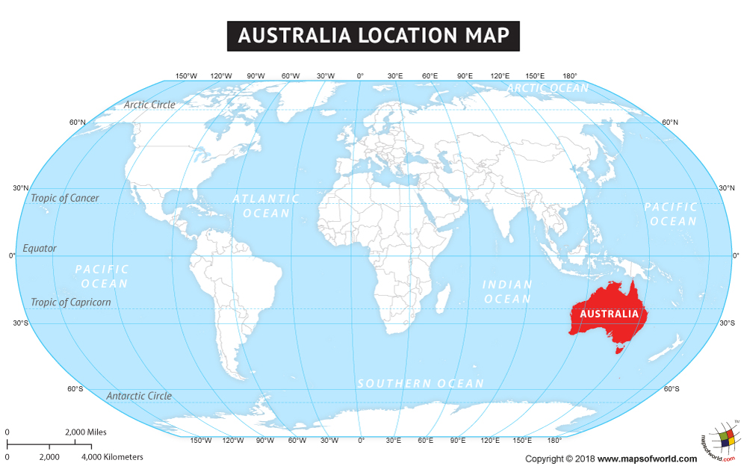

Sydney Opera House is one of the most famous sites in Australia. (Jedna od najpoznatijih znamenitosti u Australiji je operna kuća u gradu Sydneyu. To je koncertna dvorana.)
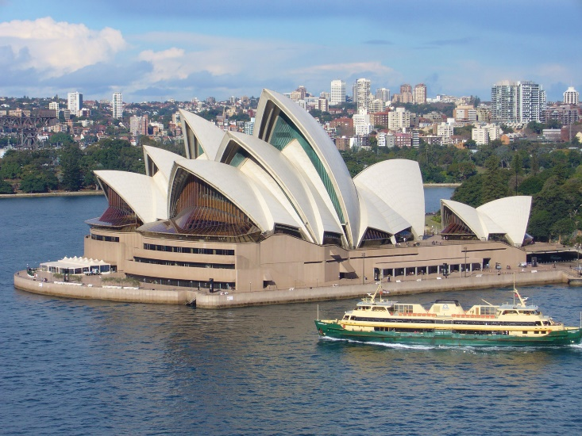
There are some strange and different animals in Australia: a duckbilled platypus, a koala bear and a kangaroo. (U Australiji se nalaza neke neobične životinje: čudnovati kljunaš, koala i klokan.) Do you recognize all the other animals in the picture? (Prepoznaješ li ostale životinje na slici?)
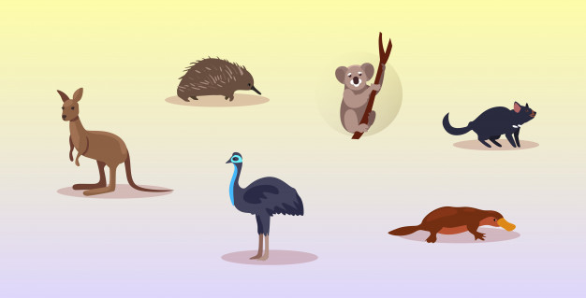

Ayer Rock is a giant rock in the middle of the dessert. (Ayers stijena je velik kameni monolit (kameno brdo) nasred australske pustinje)
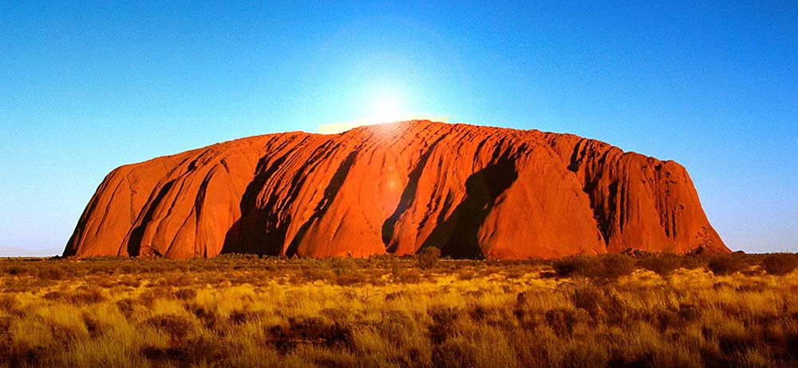

A didgeridoo is a musical instrument played by the Aboriginal people, the native people of Australia. They lived there before everybody else. (Didžeridu je glazbalo koje sviraju Aboriđini, domoroci Australije. Oni su tamo živjeli prije svih novih doseljenika.)
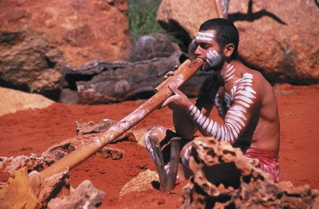

The Great Barrier Reef is filled with corrals and various sea animals. (Veliki koraljni greben pun je koralja i različitih morskih životinja.)

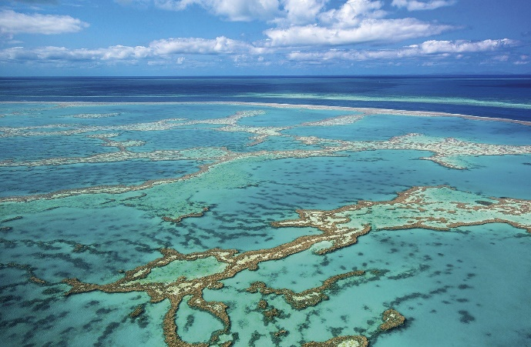
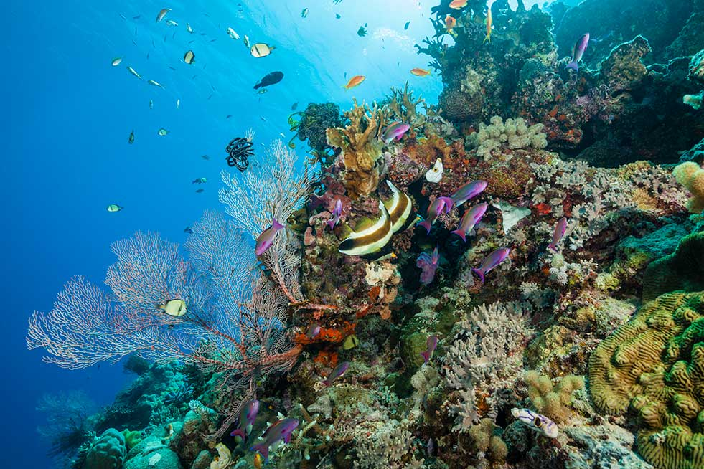

- SB, p. 61 – Culture Corner – read the questions about Australia
- WB, p. 59 – Task M Complete the text about Australia – dovrši tekst o Australiji

- copy the board into your notebooks
Uncle Phil's Relatives 20th April 2020
Australia – Down Under
Sydney Opera House, Ayers Rock, The Great Barrier Reef, the Aboriginal people

a beach – plaža outdoors – izvan kuće, na otvorenom
beach volleyball – odbojka na pijesku to go sailing - jedriti
feed animals – hraniti životinje city - grad
collect eggs – skupljati jaja farm - farma
vegetable garden – povrtnjak
tell stories – pričati priče

- SB, p. 58 (Uncle Phil's Realtives), Task B – Listen and read about Uncle Phil's relatives from Australia. Then fill in the sentences. (Slušaj snimku i pročitaj tekst o rođacima ujaka Phila. Dopuni rečenice i prepiši ih u bilježnicu.)
- snimka teksta
The Taylors live on ________________
They have _______________ and __________________ on their farm. (animals)
Their favourite season is _______________ because they can ________ around the fire, __________________________ and ________________________.

The Whites live in ____________. They live _____________________ near the beach.
In the afternoons they spend time ______________________.
They like to go ________________ and _______________________ (sports).

- HW: practice reading the text about Uncle Phil's Realatives
- učiteljici pošalji sliku bilježnice

