Where is Gizmo?
- go around the rooms in your house and say what they are called in English – napravi krug u kući i na engleskom jeziku imenuj sve sobe

- What can you see in a BEDROOM?
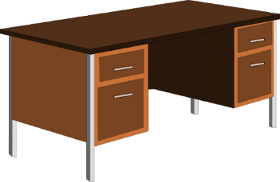
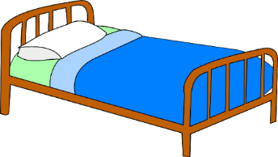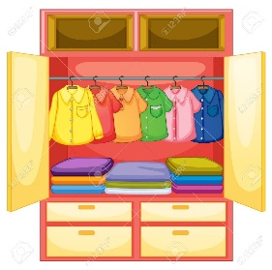
A BED A WARDROBE A DESK

- What can you see in a KITCHEN?
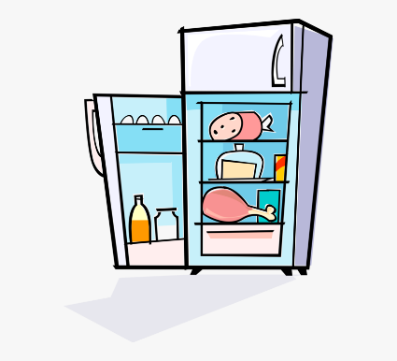
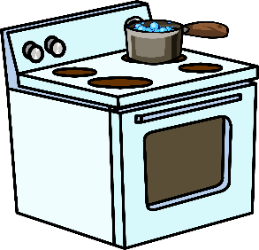
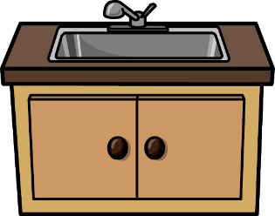
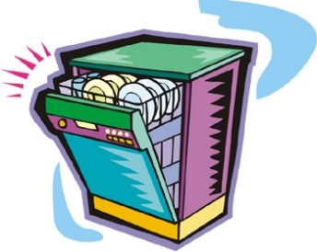

A FRIDGE A DISHWASHER A SINK A COOKER/
STOVE

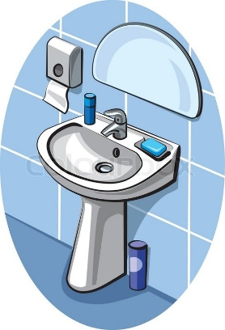
- What can you see in the BATHROOM?
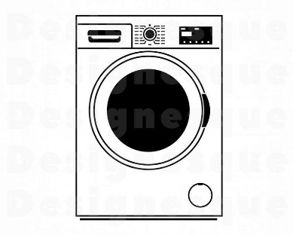
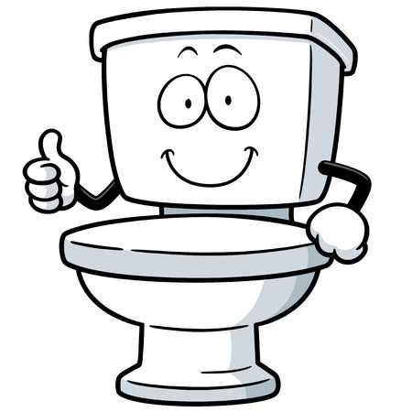

A TOILET A BATH / BATHTUB A WASHBASIN A WASHING
MACHINE

- What can you see in the LIVING ROOM?
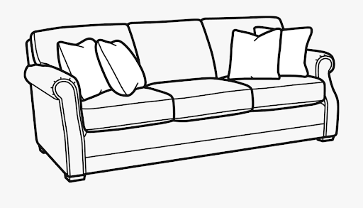
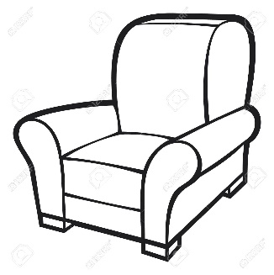
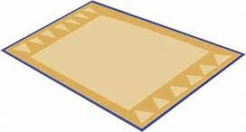

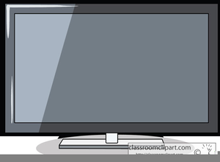
A SOFA / COUCH AN ARMCHAIR A CARPET

A TV SET / A TELEVISION

- Copy this into your notebooks. Don't forget to write the tittle. Prepiši u bilježnicu i nemoj zaboraviti dodati naslov.
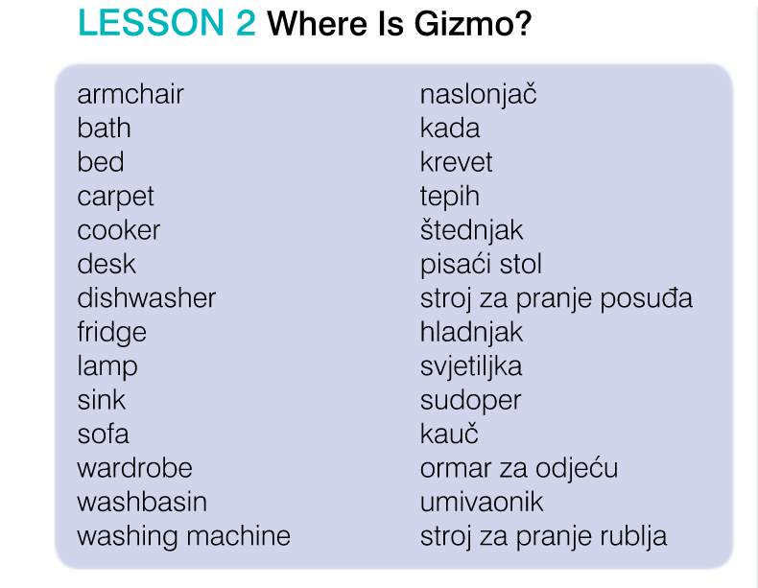

- open your STUDENT BOOK on page 54 and look at the pictures in Task 1
- listen to the recording (riječi) and repeat – slušaj snimku i ponovi riječi
- listen and match the picture to the word below – slušaj i spoji sliku s riječi (Task 2)

- Task 3 – Look at the pictures. Name all the rooms you can see.
- listen to the recording (Where is Gizmo?) and tick (stavi kvačicu) all the rooms Gizmo is in. (HINT: Gizmo je u 4 sobe)

- Task 4 – Look at the pictures in Task 3. Read the questions and circle the correct answer.

2. Nalazi li se kada u kuhinji? 5. Nalazi li se veliki krevet u spavaćoj sobi?
3. Nalazi li se štednjak u dnevnoj sobi? 6. Nalaze li se 4 stolice u blagavaoni?
4. Nalazi li se WC školjka u kupaonici?

- HOMEWORK: Workbook, page 66 (naslov Where is Gizmo?), Task 1 – dodaj slova koja nedostaju; Task 2 – zaokruži riječ koja ne paše
- sliku riješene domaće zadaće pošalji Teacher Maji na pregled

