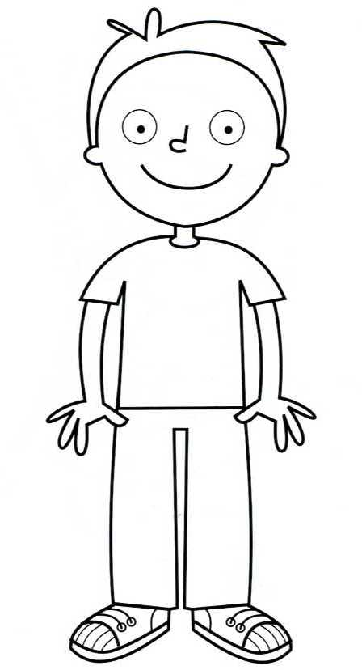
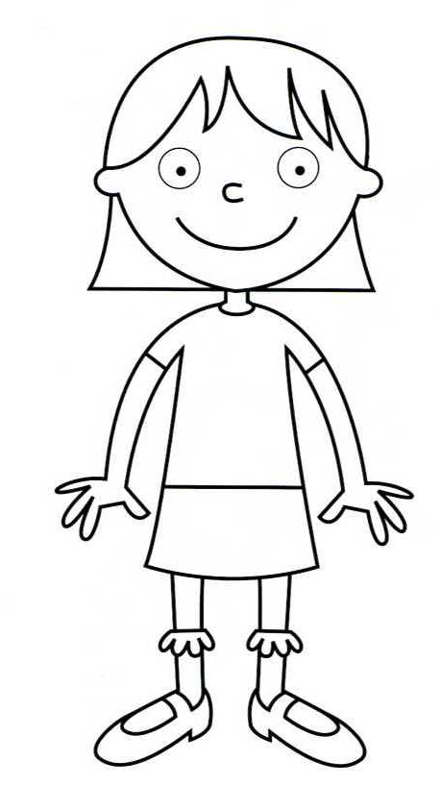
CLOTHES AND COLOURS
Read and colour.

- Her hair is blonde.
- Her t-shirt is pink.
- Her eyes are green.
- Her skirt is purple.
- Her socks are orange.
- Her shoes are yellow.
- His hair is brown.
- His eyes are blue.
-His trainers are purple and yellow.
- His T-shirt is blue.
- His jeans are red.

HELLO!!

- ponovimo nazive za odjeću, boje i dijelove tijela. Pročitaj što piše i oboji. (ako nemaš printer onda pročitaj što piše i nacrtaj u bilježnicu)

- Today you are learning about the weather. – Danas ćemo učiti o vremenskim prilikama.
- Look at the pictures! – Pogledaj slike!
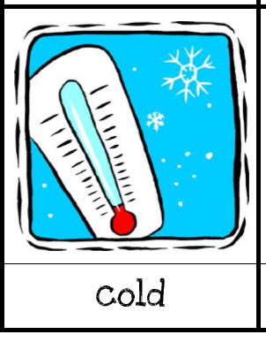
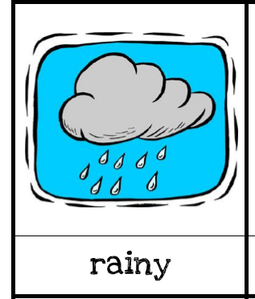
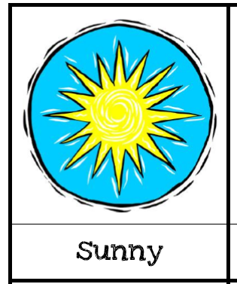
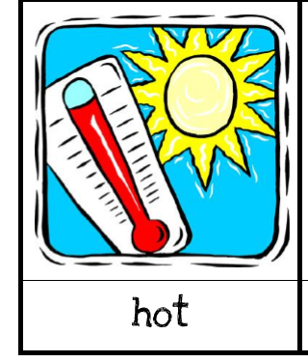

- Listen! – Poslušaj kako se izgovaraju. Poveznica na snimku.
- Open you student book on page 44. Look at the pictures in Task 1 and read the sentence below. – Otvori udžbenik na stranici 44. Pogledaj slike u zadatku 1 i pročitaj rečenice ispod slika.
- Listen and watch The Weather Song. – Poslušaj i pogledaj video za pjesmu The Weather Song.
- What’s the weather like today? – Kakvo je danas vrijeme?

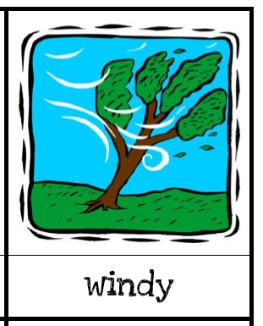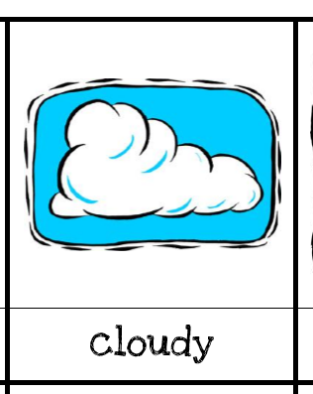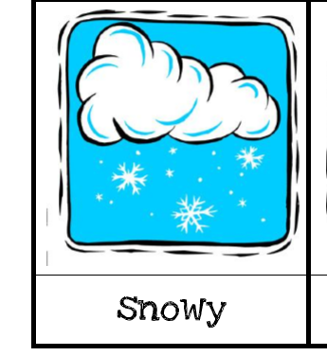

- Copy the board into your notebook. – Prepiši plan ploče u bilježnicu.

The Weather Puzzle

sunny – sunčano warm - toplo
raining – kišovito windy - vjetrovito
cold – hladno cloudy - oblačno
hot – vruće snowy – pada snijeg

- HOMEWORK – nacrtaj 4 vremenske prilike koji si naučio/la
- sliku bilježnice pošalji Teacher Maji na pregled

Goodbye!!
Teacher Maja

