LISTIĆ 1

ı. Oboji:





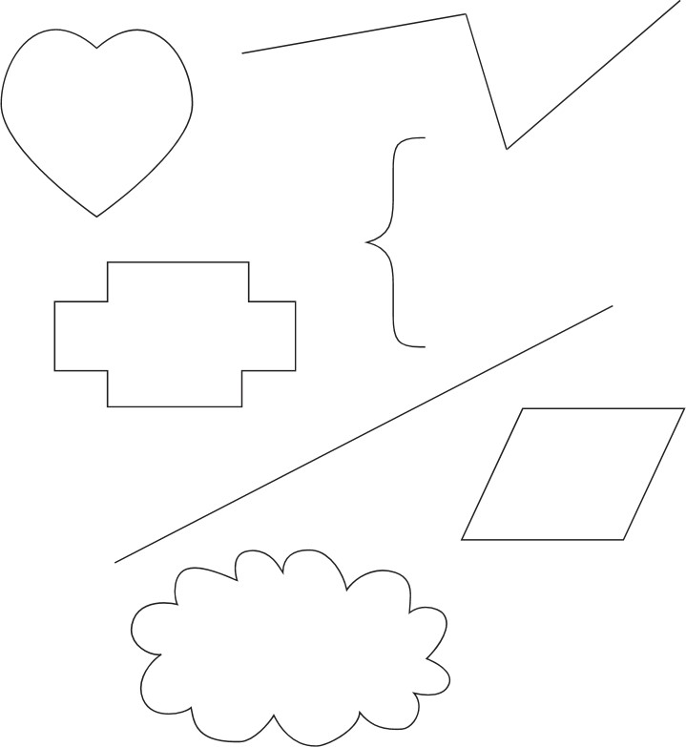

BROJEVNA CRTA

1. Upiši brojeve koji nedostaju.



1. Oboji brojeve koji su zalutali.

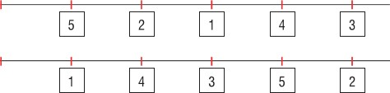

1. Broji unatrag.

5, 3,



1. Upiši broj 3. Upiši broj 5.



Kojl se broj nalazi izmedu brojeva 3 5?

Prekriži slovo O.

ON IVO TA OKO JA TI

OVA ETO MI ONI KOLA

Prekriži slovo J.

MOJ NIT KOKA JA TKO JELA BAJA JAJE VIDI JOKA NIJE

Prekriži riječ JA.

EVO JA NIJE JESU JAJA ONA KOJA JE JA JU AJ MOJA

Prekriži riječ VI.

VIKA LUK VI IVO VINO NOVI SVI VILE EVA VI OVI

Prekriži riječ ON.

ON TAJ TO ONI ONA ON NO

ONO NINO ON TON NOTA NOV

Pronađi i zaokruži **POČETNO** slovo u nazivu slike.

|  |  |  |  |  |  |  |
| --- | --- | --- | --- | --- | --- | --- |
| leptir |  | M |  |  | Z |  |
|  |  | L |  |  | Š |
|  | T |  | S |  |  |

|  |  |  |  |  |  |  |
| --- | --- | --- | --- | --- | --- | --- |
| hobotnica |  | R |  |  | H |  |
|  |  | G |  |  | Š |
|  | T |  | S |  |  |

|  |  |  |  |  |  |  |
| --- | --- | --- | --- | --- | --- | --- |
| sunce |  | N |  |  | I |  |
|  |  | G |  |  | Š |
|  | K |  | S |  |  |

|  |  |  |  |  |  |  |
| --- | --- | --- | --- | --- | --- | --- |
| kupaona |  | N |  |  | I |  |
|  |  | G |  |  | Š |
|  | K |  | S |  |  |

|  |  |  |  |  |  |  |
| --- | --- | --- | --- | --- | --- | --- |
| zec |  | Č |  |  | U |  |
|  |  | Ć |  |  | Ž |
|  | Z |  | Đ |  |  |

|  |  |  |  |  |  |  |
| --- | --- | --- | --- | --- | --- | --- |
| autobus |  | E |  |  | Š |  |
|  |  | A |  |  | O |
|  | T |  | I |  |  |

|  |  |  |  |  |  |  |  |
| --- | --- | --- | --- | --- | --- | --- | --- |
| sat |  |  | U |  |  | S |  |
|  |  |  | G |  |  | F |
|  |  | V |  | I |  |  |

Što je na slici? Pročitaj i zaokruži riječ.

|  |  |  |  |  |  |
| --- | --- | --- | --- | --- | --- |
| ruž |  |  | krivo |  | prvo |
|  | muž |  |  |
| puž |  | drvo |  |
|  |  |  |  |  |  |
| pas |  |  | kuća |  | vreća |
|  | glas |  |  |
| spas |  |  | veća |
|  |  |  |  |  |  |
| potok |  |  | žlica |  |  |
|  | otok |  | vile |
| top |  | vilica |  |
|  |  |  |  |  |  |
| gljiva |  | šljiva |  |  | mrak |
|  |  | rak |  |
|  | siva |  | trag |