**ŠTO JE NA SLICI? NAPIŠI I OBOJI CRTEŽE.**

**[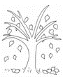](http://www.bojanke.rs/bojanke/jesen9.gif)** [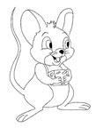](http://www.bojanke.net/zivotinje/bojanke_miseva/crtezi/5.gif) [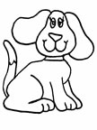](http://www.bojanke.net/zivotinje/bojanke_pasa/crtezi/2.gif) [](http://www.bojanke.net/zivotinje/bojanke_pcelice/crtezi/2.gif) 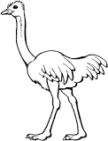 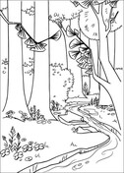

\_\_\_ \_\_\_ \_\_\_ \_\_\_ \_\_\_ \_\_\_ \_\_\_ \_\_\_ \_\_\_ \_\_\_ \_\_\_ \_\_\_ \_\_\_ \_\_\_ \_\_\_ \_\_\_ \_\_\_ \_\_\_ \_\_\_ \_\_\_ \_\_\_

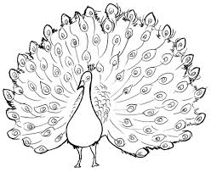  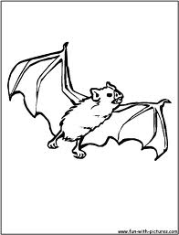 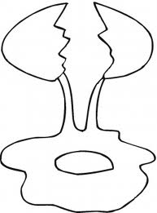 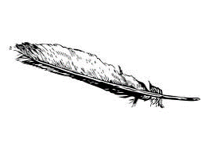

\_\_\_ \_\_\_ \_\_\_ \_\_\_ \_\_\_ \_\_\_ \_\_\_ \_\_\_ \_\_\_ \_\_\_ \_\_\_ \_\_\_ \_\_\_ \_\_\_ \_\_\_ \_\_\_ \_\_\_ \_\_\_ \_\_\_ \_\_\_ \_\_\_

MCj02979350000[1]

**ISPOD SLIKE NAPIŠI RIJEČ.**



MCj04414070000[1]MCj04046130000[1]

MCj03965760000[1]MCj03615080000[1]MCHH01263_0000[1]

MCj04302330000[1]

MCj03348240000[1]

MCj04240140000[1]MCj01010080000[1]

MCAN04317_0000[1]

