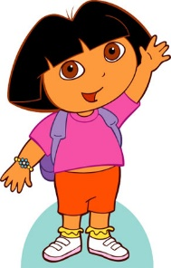
OBOJI SLOVO KOJE SE RAZLIKUJE OD OSTALIH!

a a o a a

m n m m m

e u u u u

s s s š s

v l v v v

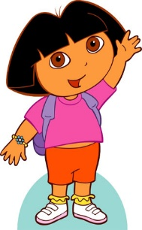
OBOJI SLOVO KOJE SE RAZLIKUJE OD OSTALIH!

b d b b b

p p p p b

č č ć č č

š š č š š

k k h k k

OBOJI SLOVO KOJE SE RAZLIKUJE OD OSTALIH!

r r r n r

t f f f f

lj lj lj lj nj

n n n u n

d d d đ d

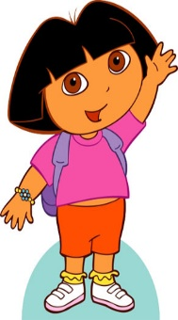
ISTOM BOJIM OBOJI PAROVE (VELIKO I MALO SLOVO)!

a e i o
E O A I

u M j L
l u m J

v S L Š
š V s l

Zbrajanje i oduzimanje brojeva do 5

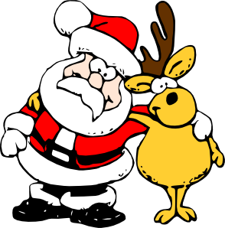
1+1= 5-4= 2+0=
4-2= 1+3= 2-0=
5+0= 4-1= 2+1=
5-3= 3+0= 4-3=
2+2= 5-0= 4+1=
2-2= 1+0= 3 -1=
4+0= 3-2= 2+3=
3-0= 1+4= 4-0=
3+2= 5-1= 0+0=

